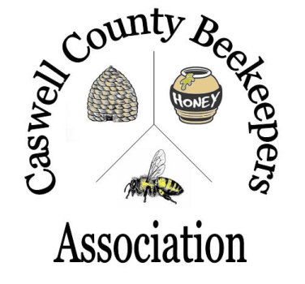
Caswell County Beekeepers Association
Make Check Payable To:
Caswell County Beekeepers Association
(or CCBA)

Mail Form with Payment To Treasurer:
Caswell County Beekeepers Association
P.O. Box 84
Yanceyville, NC 27379

2018 Beginning Beekeeping Course
Registration Form

Welcome to the Caswell County Beekeepers Association 2018 beginning beekeeping course. The course runs from January 10 to March 7 with a field day on March 17. Classes will be held on Wednesday evenings from 6:30PM to 8:30PM in the basement of the Agriculture Building next to the Historic Courthouse in downtown Yanceyville, NC.

Please fill out the information below and return with payment by December 22 so that we can order and receive books and materials in time for the beginning of classes.

Student Information: Date:

First Name Middle Initial Last Name

Street Address

City/Town State County Zip

Home phone number Cell phone number

Email Address

Registration Fees Cost

 Individual $70.00

--- OR ---

 Accompanying family member or friend (see note)** $35.00
Name of the person you will be accompanying: ________________________
Name

Payment Type: Cash  Check  Check #
** Note: For accompanying family member or friend, the $45 fee does not include book or materials. You will need to share books and materials.

Please
use
one
registration
form
per
student

